# Rossmoyne Senior High School

### Year 12 Trial WACE Examination, 2015

### Question/Answer Booklet

**SOLUTIONS**

# MATHEMATICS

# SPECIALIST 3CD

## Section Two:

## Calculator-assumed

|  |  |  |  |  |  |  |  |  |
| --- | --- | --- | --- | --- | --- | --- | --- | --- |
| Student Number: In figures |  |  |  |  |  |  |  |  |

In words

Your name

## Time allowed for this section

Reading time before commencing work: ten minutes

Working time for this section: one hundred minutes

## Materials required/recommended for this section

##### *To be provided by the supervisor*

This Question/Answer Booklet

Formula Sheet (retained from Section One)

##### *To be provided by the candidate*

Standard items: pens (blue/black preferred), pencils (including coloured), sharpener,

correction fluid/tape, eraser, ruler, highlighters

Special items: drawing instruments, templates, notes on two unfolded sheets of A4 paper, and up to three calculators approved for use in the WACE examinations

## Important note to candidates

No other items may be taken into the examination room. It is **your** responsibility to ensure that you do not have any unauthorised notes or other items of a non-personal nature in the examination room. If you have any unauthorised material with you, hand it to the supervisor **before** reading any further.

## Structure of this paper

|  |  |  |  |  |  |
| --- | --- | --- | --- | --- | --- |
| Section | Number of questions available | Number of questions to be answered | Working time (minutes) | Marks available | Percentage of exam |
| Section One:  Calculator-free | 7 | 7 | 50 | 50 | 33⅓ |
| Section Two:  Calculator-assumed | 13 | 13 | 100 | 100 | 66⅔ |
|  | | | **Total** | 150 | 100 |

## Instructions to candidates

1. The rules for the conduct of examinations are detailed in the school handbook. Sitting this examination implies that you agree to abide by these rules.
2. Write your answers in this Question/Answer Booklet.
3. You must be careful to confine your response to the specific question asked and to follow any instructions that are specified to a particular question.
4. Spare pages are included at the end of this booklet. They can be used for planning your responses and/or as additional space if required to continue an answer.

* Planning: If you use the spare pages for planning, indicate this clearly at the top of the page.
* Continuing an answer: If you need to use the space to continue an answer, indicate in the original answer space where the answer is continued, i.e. give the page number. Fill in the number of the question that you are continuing to answer at the top of the page.

1. **Show all your working clearly**. Your working should be in sufficient detail to allow your answers to be checked readily and for marks to be awarded for reasoning. Incorrect answers given without supporting reasoning cannot be allocated any marks. For any question or part question worth more than two marks, valid working or justification is required to receive full marks. If you repeat any question, ensure that you cancel the answer you do not wish to have marked.
2. It is recommended that you **do not use pencil**, except in diagrams.
3. The Formula Sheet is **not** to be handed in with your Question/Answer Booklet.

Section Two: Calculator-assumed (100 Marks)

This section has**thirteen (****13)** questions. Answer **all** questions. Write your answers in the spaces provided.

Working time: 100 minutes.

Question 8 (6 marks)

If  and , determine the exact value of  when .



Question 9 (8 marks)

The popularity of four contestants at the end of each round of a talent show can be modelled by the matrix equation below, where  represent the percentage of all votes cast for each of the four contestants at the conclusion of round n.



(a) Explain the significance of the three zero elements in the transition matrix. (2 marks)

No one who votes for A or D in one round will vote for C in the next round and no one who votes for C in one round will vote for D in the next round.

At the end of round two, the percentage of votes cast for A, B, C and D were 19%, 30%, 5% and 36% respectively.

(b) If the competition finishes at the end of round six, determine which competitor will be the most popular at that time and state the percentage of votes cast for this competitor.

(3 marks)



A is most popular, with 32.6% of votes.

(c) Rank the competitors in order of popularity at the end of round one. Justify your answer.

(3 marks)



Ranking is D, B, C and A.

Question 10 (7 marks)

The graph of  is shown below.

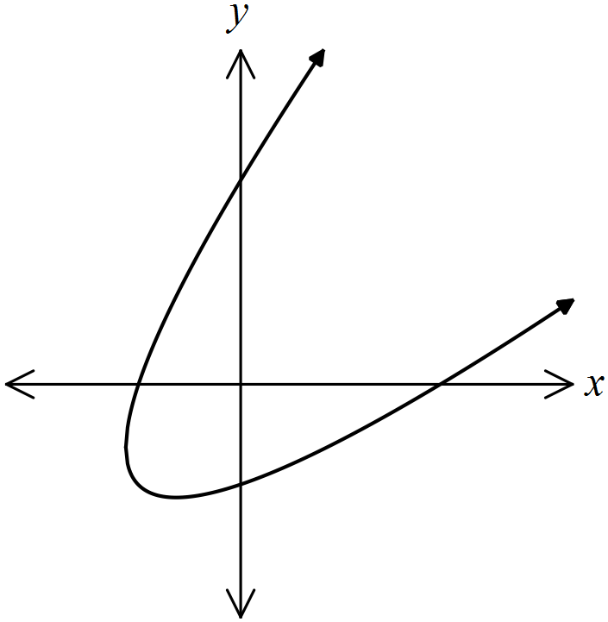

(a) Determine the coordinates of all axes intercepts. (2 marks)



(b) Show that the gradient at any point on the curve is given by . (3 marks)



(c) Determine the equation of the tangent to the curve at the point where the curve intersects the positive y-axis. (2 marks)



Question 11 (8 marks)

The vector equation of plane P is .

(a) Show that the vector  is perpendicular to plane P. (3 marks)



Since  are not parallel and  is perpendicular to both, then it is also perpendicular to plane P.

(b) Determine a vector equation of the plane in the form . (2 marks)



(c) Determine where the line  intersects the plane P. (3 marks)



Question 12 (7 marks)

Let a, b and c be integers such that .

(a) State which **one** of the following statements is true, and supply counterexamples to disprove the two false statements:

(3 marks)

(i) c is always even.

.

(ii) At least one of the integers a or b must be odd.

.

(iii) At least one of the integers a or b must be even.

True

(b) Prove, by contradiction, the true statement from (a). (4 marks)

Assume that a is not even **and** b is not even.

Then  and , where n and m are integers.



The assumption implies that , and hence c, must be even, but the counterexample from (a)(i) shows that this is not true, and so we have a contradiction.

Thus, either a is even or b is even.

Question 13 (9 marks)

The diagram below shows the quadrilateral OABC of area 6 square units, where O is at the origin and A, B and C have coordinates (3, 1), (0, 3) and (-1, 2).

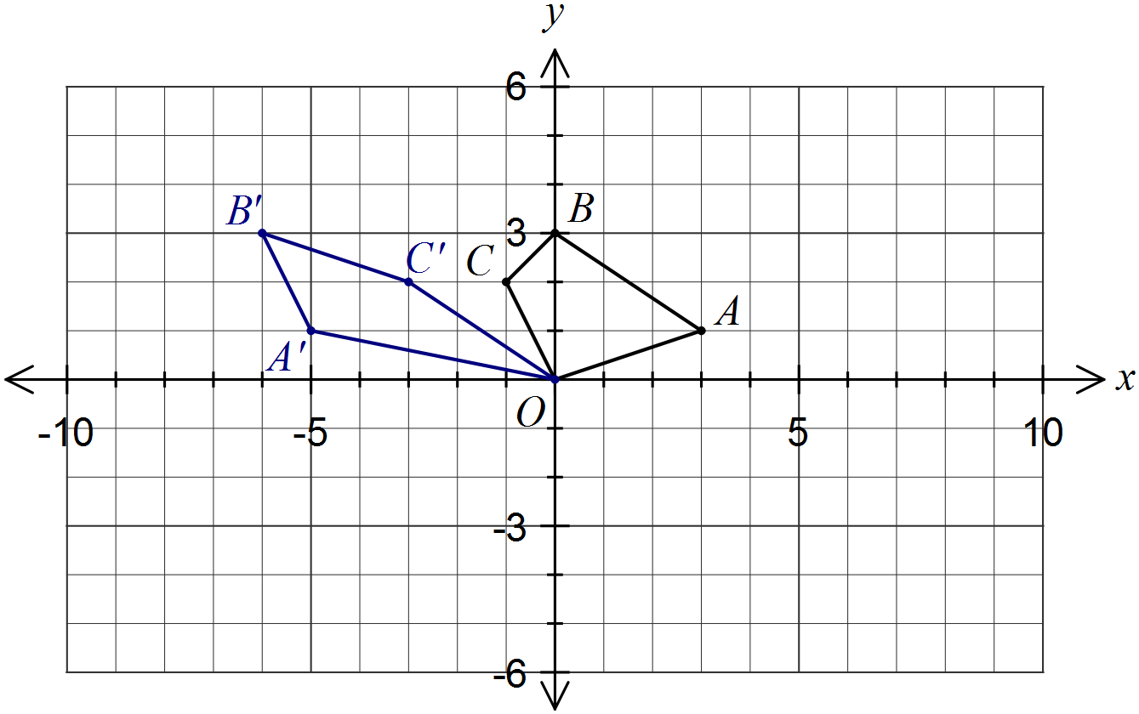

(a) OABC is transformed by a linear transformation P to OA'B'C', where the coordinates of A' and B' are (-5, 1) and (-6, 3) respectively.

(i) Determine the transformation matrix P. (2 marks)



(ii) State the coordinates of C' and draw the quadrilateral OA'B'C' on the diagram above. (2 marks)



(b) Transformation P is the equivalent of transformation Q followed by transformation R, where R is a reflection in the y-axis.

(i) Determine the appropriate transformation matrix for Q. (2 marks)



(ii) Describe transformation Q. (1 mark)

Shear, factor 2, parallel to the x-axis.

(c) OA'B'C' is transformed by the matrix  to OA''B''C''.

Determine the area of OA''B''C''. (2 marks)

Original area of OABC is 6 sq units.

P has determinant of -1, so P does not change area.

S has determinant 81, so area of OA''B''C'' is  sq units.

Question 14 (9 marks)

(a) Use inequalities to describe the shaded region in the complex plane below. (3 marks)

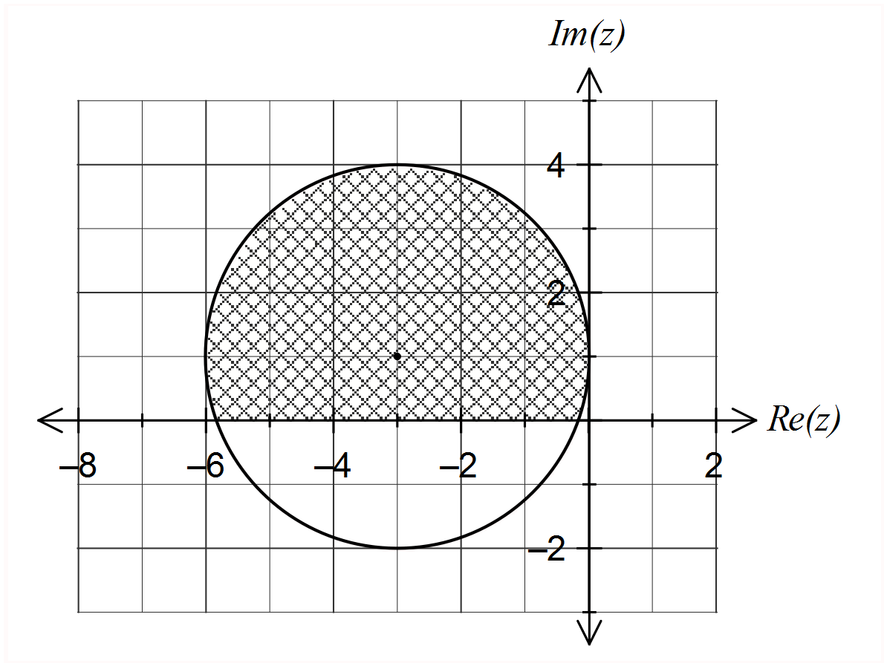



(b) The set of complex numbers that satisfy  is shown below.

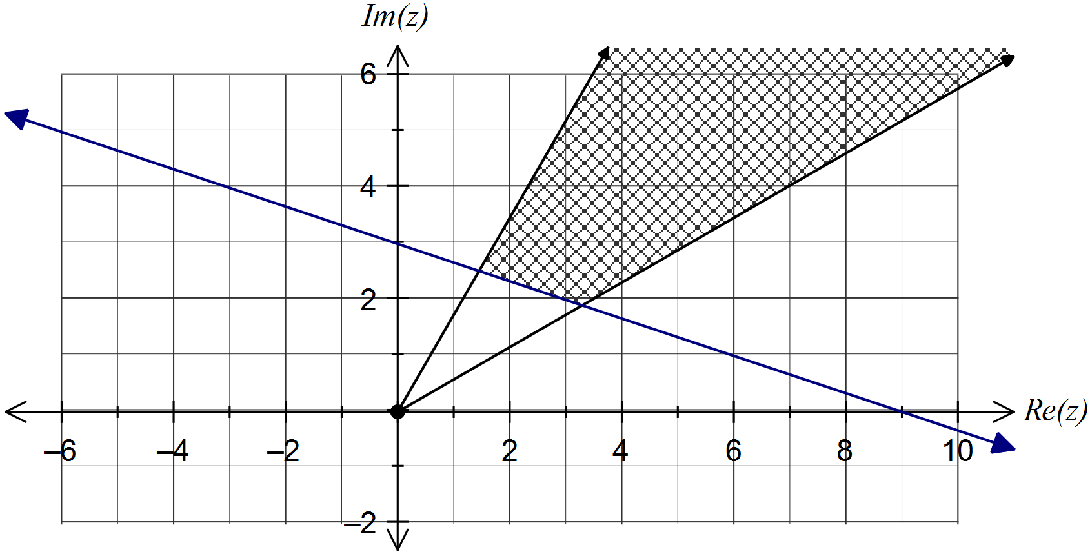

(i) Add the set of complex numbers  to the diagram and clearly shade the region that satisfies both inequalities. (3 marks)

(ii) Determine, in exact form, the minimum value of  in the region that satisfies both inequalities. (3 marks)



Question 15 (7 marks)

At 0830 on a windless day, a light aircraft takes off from an airport and flies due east at a constant 300 km/h. At the same instant, a passenger aircraft is 50 km due south of the airport and is flying directly towards the airport at a constant speed of 400 km/h.

Determine the rate, to the nearest km/h, that the distance between the two aircraft is changing at the instant the passenger plane is 30 km from the airport.

Let a and b be distance of light and passenger aircraft from airport respectively.



Distance is decreasing at 224 km/h.

Question 16 (9 marks)

The path of a particle is given by the parametric equations  and , where x and y are measured in metres and t is the time in seconds since motion began.

(a) State the minimum and maximum values of x and y. (2 marks)



(b) Determine the value of  at A, the position of the particle when . (2 marks)



(c) Determine the Cartesian equation of the path of the particle. (2 marks)



(d) Sketch the path of the particle, indicating the position of A. (3 marks)

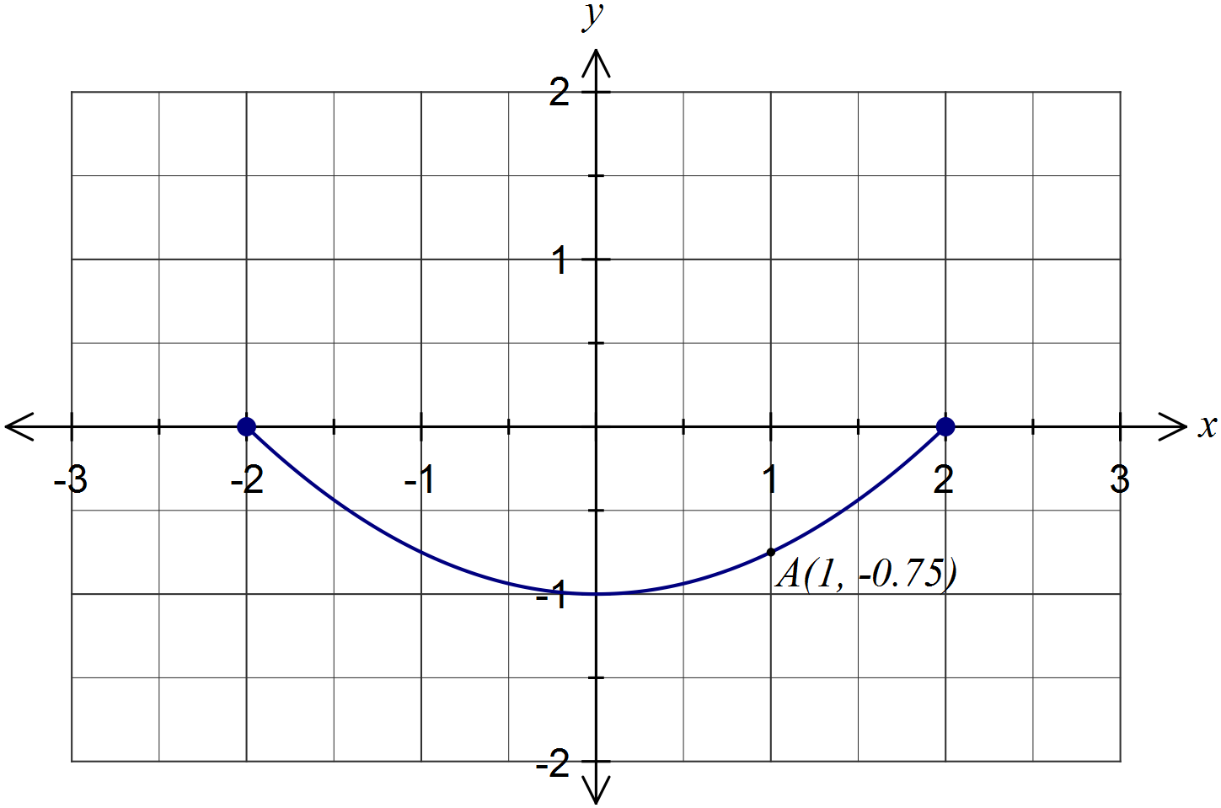

Question 17 (8 marks)

A simple pendulum has a point mass on the end of a long string.

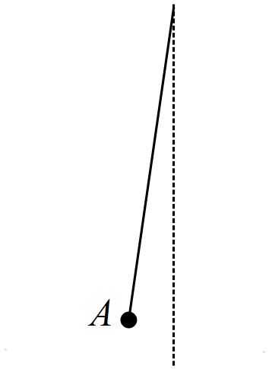

The mass, initially stationary, is released from position A. The mass swings a total distance of 48 cm away from A and then swings back again, returning to its initial position after a total of six seconds. The pendulum repeats this motion, with no measurable loss in amplitude from swing to swing.

The horizontal distance, x cm, of the point mass from A, t seconds after release, can be modelled by the equation , where a, n, b and c are positive constants.

(a) Express the acceleration  in terms of x, n and c. (2 marks)



(b) Determine the values of the positive constants a, n, b and c. (4 marks)

Amplitude of motion: .

Period: .

Horizontal shift: .

Vertical shift: .

(c) At what time(s) during the first ten seconds is the mass moving with maximum speed?

(2 marks)

From (a), .

When .

Question 18 (5 marks)

Pyramid OABC is such that edge OC is perpendicular to the triangular base OAB, angle AOB is obtuse and the length of OC is greater than that of OA and OB. Let $\vec{OA}=$ a, $\vec{OB}=$ b and $\vec{OC}=$ c.

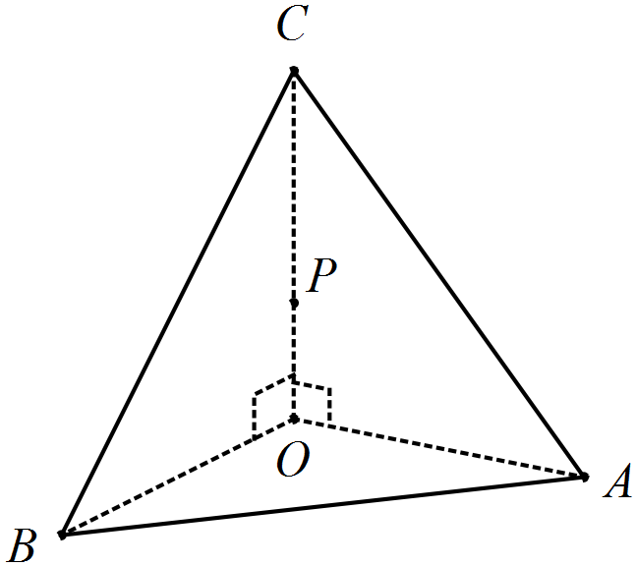

Suppose that  and P is a point on OC such that $\vec{OP}=μ\vec{OC}$ and .

(a) Express $\vec{AP}$ and $\vec{BP}$ in terms of a, b and c. (1 mark)

$\vec{AP}$. $\vec{BP}$

(b) Prove that when , . (4 marks)



Question 19 (8 marks)

(a) Using your calculator, or otherwise, determine the real part of

(i) . (1 mark)



(ii) . (1 mark)



(b) Using the identity  and the result from (a)(ii), show that . (3 marks)



Equate real parts:



(c) Hence show that . (3 marks)



Question 20 (9 marks)

A small body A leaves position  metres, and moves with a constant velocity of  metres per second.

(a) A small body B leaves  meters five seconds later and collides with A after another ten seconds. Determine the constant velocity of B. (3 marks)



(b) Another small body C leaves  metres at the same time as A, moving with a constant velocity of  metres per second. In the subsequent motion, the minimum distance between A and C occurs exactly four seconds later. Determine all possible values of x. (6 marks)



Additional working space

Question number: _________

Additional working space

Question number: _________

Additional working space

Question number: _________

Additional working space

Question number: _________

This examination paper may be freely copied, or communicated on an intranet, for non-commercial purposes within educational institutes that have purchased the paper from WA Examination Papers provided that WA Examination Papers is acknowledged as the copyright owner. Teachers within Rossmoyne Senior High School may change the paper provided that WA Examination Paper's moral rights are not infringed.

Copying or communication for any other purposes can only be done within the terms of the Copyright Act or with prior written permission of WA Examination papers.

*Published by WA Examination Papers*

*PO Box 445 Claremont WA 6910*